2015年12月大学英语四级考试真题(第3套)
Part Ⅰ Writing ( 30 minutes)
Directions: For this part, you are allowed 30 minutes to write an essay commenting on the saying" Never go out there to see what happens, go out there to make things happen." You can cite xamples to illustrate the importance of being participants rather than mere on lookers inlife. You should write at least 120 words but no more than 180 words.

Part Ⅱ Listening Comprehension ( 30 minutes)
听力音频地址：
http://wximg.233.com/attached/media/20160426/20160426161254_0664.mp3
Section A
Directions : In this section, you will hear 8 short conversations and 2 long conversations.At the end of each conversation, one or more questions will be asked about what was said.Both the conversation and the questions will be spoken only once.After each question there will bea pause.During the pause, you must read the four choices marked A, B, Cand D,and decide which is the best answer. Then mark the corresponding letter on Answer
Sheet 1 with a single line through the centre.
1.A.Children should be taught to be more careful.
B.Children shouldn't drink so much orange juice.
C.There is no need for the man to make such a fuss.
D.Timmy should learn to do things in the right way.
- A.Fitness training.
B.The new job offer.
C.Computer programming.
D.Directorship of the club.
3.A.He needs to buy a new sweater.
B.He has got to save on fuel bills.
C.The fuel price has skyrocketed.
D.The heating system doesn't work.
- A.Committing theft.
B.Taking pictures.
C.Window shopping.
D.Posing for the camera.
- A.She is taking some medicine.
B.She has not seen a doctor yet.
C.She does not trust the man's advice.
D.She has almost recovered from the cough.
- A.Pamela's report is not finished as scheduled.
B.Pamela has a habit of doing things in a hurry.
C.Pamela is not good at writing research papers.
D.Pamela's mistakes could have been avoided.
7.A.In the left-luggage office.
B.At the hotel reception.
C.In a hotel room.
D.At an airport.
- A.She was an excellent student at college.
B.She works in the entertainment business.
C.She is fond of telling stories in her speech.
D.She is good at conveying her message.
Questions 9 to 11 are based on the conversation you have just heard.
9.A.Arranging the woman's appointment with Mr.Romero.
B.Fixing the time for the designer's latest fashion show.
C.Talking about an important gathering on Tuesday.
D.Preparing for the filming on Monday morning.
10.A.Her travel to Japan.
B.The awards ceremony.
C.The proper hairstyle for her new role.
D.When to start the make-up session.
11.A.He is Mr.Romero's agent.
B.He is an entertainment journalist.
C.He is the woman's assistant.
D.He is a famous movie star.
Questions 12 to 15 are based on the conversation you have just heard.
- A.Make an appointment for an interview.
B.Send in an application letter.
C.Fill in an application form.
D.Make a brief self-introduction on the phone.
13.A.Someone having a college degree in advertising.
B.Someone experienced in business management.
C.Someone ready to take on more responsibilities.
D.Someone willing to work beyond regular hours.
- A.Travel opportunities.
B.Handsome pay.
C.Prospects for promotion.
D.Flexible working hours.
- A.It depends on the working hours.
B.It is about 500 pounds a week.
C.It will be set by the Human Resources.
D.It is to be negotiated.
Section B
Directions..In this section, you will hear 3 short passages.At the end of each passage, you will hear some questions. Both the passage and the questions will be spoken only once.After youhear a question, you must choose the best answer from the four choices marked A., B,Cand D..Then mark the corresponding letter on Answer Sheet 1 with a single line through the center.
Passage One
Questions 16 to 19 are based on the passage you have just heard.
16.A.To give customers a wider range of choices.
B.To make shoppers see as many items as possible.
C.To supply as many varieties of goods as it can.
D.To save space for more profitable products.
- A.On the top shelves.
B.On the bottom shelves.
C.On easily accessible shelves.
D.On clearly marked shelves.
18.A.Many of them buy things on impulse.
B.A few of them are fathers with babies.
C.A majority of them are young couples.
D.Over 60% of them make shopping lists.
19.A.Sales assistants promoting high margin goods.
B.Sales assistants following customers around.
C.Customers competing for good bargains.
D.Customers losing all sense of time.
Passage Two
Questions 20 to 22 are based on the passage you have just heard.
20.A.Teaching mathematics at a school.
B.Doing research in an institute.
C.Studying for a college degree.
D.Working in a hi-tech company
- A.He studied the designs of various clocks.
B.He did experiments on different materials.
C.He bought an alarm clock with a pig face.
D.He asked different people for their opinions.
- A.Its automatic mechanism.
B.Its manufacturing process.
C.Its way of waking people up.
D.Its funny-looking pig face.
Passage Three
Questions 23 to 25 are based on the passage you have just heard.
23.A.It is often caused by a change of circumstances.
B.It actually doesn't require any special treatment.
C.It usually appears all of a sudden.
D.It generally lasts for several years.
24.A.They cannot mix well with others.
B.They irrationally annoy their friends.
C.They depend heavily on family members.
D.They blame others for ignoring their needs.
- A.They lack consistent support from peers.
B.They doubt their own popularity.
C.They were born psychologically weak.
D.They focus too much on themselves.
Section C
Directions: In this section, you will hear a passage three times.When the passage is read for the first time, you should listen carefully for its general idea.When the passage is read for the second time, you are required to fill in the blanks with the exact words you have justheard.Finally, when the passage is read for the third time, you should check what you have written.
There was a time when any personal information that was gathered about us was typed on a piece of paper and26 in a file cabinet.It could remain there for years and, often27, never reach the outside world.
Things have done a complete about-face since then.28 the change has been the astonishingly29 development in recent years of the computer.Today, any data that is 30 about us in one place or another--and for one reason or another--can be stored in a computer bank.It can then be easily passed to other computer banks.They are owned by individuals and by private businesses and corporations, lending 31 , direct mailing and telemarketing firms, credit bureaus, credit card companies, and32 at the local, state, and federal level.
A growing number of Americans are seeing the accumulation and distribution of computerized data as a frightening33 of their privacy.Surveys show that the number of worried Americans has been steadily growing over the years as the computer becomes increasingly 34, easier to operate, and less costly to purchase and maintain.In 1970, a national survey showed that 37 percent of the people35felt their privacy was being invaded.Seven years later, 47 percent expressed the same worry.Arecent survey by a credit bureau revealed that the number of alarmed citizens had shot up to 76percent.

Part Ⅲ Reading Comprehension(40 minutes)
Section A
Directions: In this section, there is a passage with ten blanks.You are required to select one word for each blank from a list of choices given, in a word bank following the passage.Read the passage through carefully before making your choices. Each.choice in the bank is identified by a letter.Please mark the corresponding letter for each item on Answer Sheet2 with a single line through the center.You may not use any of the words in the bank more than once.
Questions 36 to 45 are based on the following passage.
Children do not think the way adults do.For most of the first year of life, if something is out of sight, it's out of mind.If you cover a baby's36toy with a piece of cloth, the baby thinks the toyhas disappeared and stops looking for it.A 4-year-old may 37 that a sister has more fruit juicewhen it is only the shapes of the glasses that differ, not the38 of juice.
Yet children are smart in their own way.Like good little scientists, children are always testing their child-sized39 about how things work.When your child throws her spoon on the floor for the sixth time as you try to feed her, and you say, "That's enough! I will not pick up your spoon again!"
the child will 40 test your claim.Are you serious? Are you angry? What will happen if she throws the spoon again? She is not doing this to drive you41; rather, she is learning that her desires and yours can differ, and that sometimes those42 are important and sometimes they are not.
How and why does children's thinking change? In the 1920s, Swiss psychologist Jean Piaget proposed that children's cognitive (认知的) abilities unfold 43, like the blooming of a flower,almost independent of what else is44in their lives.Although many of his specific conclusions havebeen45 or modified over the years, his ideas inspired thousands of studies by investigators all over the world.
A. advocate
B. amount
C. confirmed
D. crazy
E. definite
F. differences
G. favorite
H. happening
I. Immediately
J. Naturally
K. Obtaining
L. Primarily
M. Protest
N. Rejected
O. theories
Section B
Directions: In this section, you are going to read a passage with, ten statements attached to it. Each statement contains information given in one of the paragraphs.Identify the paragraph from which the information is derived.You may choose a paragraph more than once.
Each paragraph is marked with a letter. Answer the questions by marking the corresponding letter on Answer Sheet 2.The Perfect Essay
A.Looking back on too many years of education, I can identify one truly impossible teacher.Shecared about me, and my intellectual life, even when I didn't.Her expectations were high--impossibly so.She was an English teacher.She was also my mother.
B.When good students turn in an essay, they dream of their instructor returning it to them in exactly the same condition, save for a single word added in the margin of the final page : "Flawless." This dream came true for me one afternoon in the ninth grade.Of course, I had heard that genius could show itself at an early age, so I was only slightly taken aback that I had achieved perfection at the tender age of 14.Obviously, I did what any professional writer would do; I hurried off to spread thegood news.I didn't get very far.The first person I told was my mother.
C.My mother, who is just shy of five feet tall, is normally incredibly soft-spoken, but on the rareoccasion when she got angry, she was terrifying.I am not sure if she was more upset by my hubris(得意忘形) or by the fact that my English teacher had let my ego get so out of hand.In any event,my mother and her red pen showed me how deeply flawed a flawless essay could be.At the time,I am sure she thought she was teaching me about mechanics, transitions (过渡), structure, style and voice.But what I learned, and what stuck with me through my time teaching writing at Harvard, was a deeper lesson about the nature of creative criticism.
D.First off, it hurts.Genuine criticism, the type that leaves a lasting mark on you as a writer, also leaves an existential imprint (印记) on you as a person.I have heard people say that a writer should never take criticism personally.I say that we should never listen to these people.
E. Criticism, at its best, is deeply personal, and gets to the heart of why we write the way we do. Theintimate nature of genuine criticism implies something about who is able to give it, namely,someone who knows you well enough to show you how your mental life is getting in the way of good writing.Conveniently, they are also the people who care enough to see you through this painful realization.For me it took the form of my first, and I hope only, encounter with writer'sblock--I was not able to produce anything for three years.
F. Franz Kafka once said: "Writing is utter solitude (独处), the descent into the cold abyss (深渊) of oneself." My mother's criticism had shown me that Kafka is right about the cold abyss, and when you make the introspective (内省的) descent that writing requires you are not always pleased by what you find.But, in the years that followed, her sustained tutoring suggested that Kafka might be wrong about the solitude.I was lucky enough to find a critic and teacher who was willing to make the journey of writing with me."It is a thing of no great difficulty," according to Plutarch, "to raise objections against another man's speech, it is a very easy matter; but to produce a better in its place is a work extremely troublesome." I am sure I wrote essays in the later years of high school without my mother's guidance, but I can't recall them.What I remember, however, is how she took up the "extremely troublesome" work of ongoing criticism.
G. There are two ways to interpret Plutarch when he suggests that a critic should be able to produce "a better in its place." In a straightforward sense, he could mean that a critic must be more talented than the artist she critiques (评论).My mother was well covered on this count.But perhaps
Plutarch is suggesting something slightly different, something a bit closer to Marcus Cicero's claim that one should "criticize by creation, not by finding fault." Genuine criticism creates a precious opening for an author to become better on his own terms--a process that is often extremely painful,but also almost always meaningful.
H. My mother said she would help me with my writing, but first I had to help myself.For each assignment, I was to write the best essay I could.Real criticism is not meant to find obvious mistakes, so if she found any--the type I could have found on my own--I had to start from scratch.From scratch.Once the essay was "flawless," she would take an evening to walk me through myerrors.That was when true criticism, the type that changed me as a person, began.
I. She criticized me when I included little-known references and professional jargon (行话).She had no patience for brilliant but irrelevant figures of speech."Writers can't bluff (虚张声势) their way through ignorance." That was news to me--I would need to freed another way to structure my daily existence.
J. She trimmed back my flowery language, drew lines through my exclamation marks and argued for the value of restraint in expression."John," she almost whispered.I leaned in to hear her:"I can'thear you when you shout at me." So I stopped shouting and bluffing, and slowly my writingimproved.
K. Somewhere along the way I set aside my hopes of writing that flawless essay.But perhaps I missed something important in my mother's lessons about creativity and perfection.Perhaps the point of writing the flawless essay was not to give up, but to never willingly finish.Whitman repeatedly reworked "Song of Myself' between 1855 and 1891.Repeatedly.We do our absolute best with apiece of writing, and come as close as we can to the ideal.And, for the time being, we settle.Incritique, however, we are forced to depart, to give up the perfection we thought we had achieved for the chance of being even a little bit better.This is the lesson I took from my mother: If perfection were possible, it would not be motivating.
46.The author was advised against the improper use of figures of speech.
47.The author's mother taught him a valuable lesson by pointing out lots of flaws in his seemingly perfect essay.
48.A writer should polish his writing repeatedly so as to get closer to perfection.
49.Writers may experience periods of time in their life when they just can't produce anything.
50.The author was not much surprised when his school teacher marked his essay as "flawless".
51.Criticizing someone's speech is said to be easier than coming up with a better one.
52.The author looks upon his mother as his most demanding and caring instructor.
53.The criticism the author received from his mother changed him as a person.
54.The author gradually improved his writing by avoiding fancy language.
55.Constructive criticism gives an author a good start to improve his writing.
Section C
Directions: There are 2 passages in this section.Each passage is followed by some questions or unfinished statements.For each of them there are four choices marked A, B, C.andD .You should decide on the best choice and mark the corresponding letter on Answer Sheet 2 with a single line through the center.
Passage One
Questions 56 to 60 are based on the following passage.
Could you reproduce Silicon Valley elsewhere, or is there something unique about it?
It wouldn't be surprising if it were hard to reproduce in other countries, because you couldn'treproduce it in most of the US either.What does it take to make a Silicon Valley?
It's the right people.If you could get the right ten thousand people to move from Silicon Valley to Buffalo, Buffalo would become Silicon Valley.
You only need two kinds of people to create a technology hub (中心) : rich people and nerds (痴迷科研的人).
Observation bears this out.Within the US, towns have become star,up hubs if and only if they have both rich people and nerds.Few startups happen in Miami, for example, because although it's full of rich people, it has few nerds.It's not the kind of place nerds like.
Whereas Pittsburgh has the opposite problem: plenty of nerds, but no rich people.The top US Computer Science departments are said to be MIT, Stanford, Berkeley, and Carnegie-Mellon.MITyielded Route 128.Stanford and Berkeley yielded Silicon Valley.But what did Carnegie-Mellon yield in Pittsburgh? And what happened in Ithaca, home of Cornell University, which is also high on the list?
I grew up in Pittsburgh and went to college at Cornell, so I can answer for both.The weather is terrible, particularly in winter, and there's no interesting old city to make up for it, as there is inBoston.Rich people don't want to live in Pittsburgh or Ithaca. So while there're plenty of hackers (电脑迷) who could start startups, there's no one to invest in them
Do you really need the rich people? Wouldn't it work to have the government invest in the nerds?
No, it would not.Startup investors are a distinct type of rich people.They tend to have a lot of experience themselves in the technology business.This helps them pick the right startups, and means they can supply advice and connections as well as money.And the fact that they have a personal stake in the outcome makes them really pay attention.
56.What do we learn about Silicon Valley from the passage?
A.Its success is hard to copy anywhere else.
B.It is the biggest technology hub in the US.
C.Its fame in high technology is incomparable.
D.It leads the world in information technology.
57.What makes Miami unfit to produce a Silicon Valley?
A.Lack of incentive for investment.
B.Lack of the right kind of talents.
C.Lack of government support.
D.Lack of famous universities.
58.In what way is Carnegie-Mellon different from Stanford, Berkeley and MIT?
A.Its location is not as attractive to rich people.
B.Its science departments are not nearly as good.
C.It does not produce computer hackers and nerds.
D.It does not pay much attention to business startups.
59.What does the author imply about Boston?
A.It has pleasant weather all year round.
B.It produces wealth as well as high-tech.
C.It is not likely to attract lots of investors and nerds.
D.It is an old city with many sites of historical interest.
60.What does the author say about startup investors?
A.They are especially wise in making investments.
B.They have good connections in the government.
C.They can do more than providing money.
D.They are rich enough to invest in nerds.
Passage Two
Questions 61 to 65 are based on the following passage.
It's nice to have people of like mind around.Agreeable people boost your confidence and allow you to relax and feel comfortable.Unfortunately, that comfort can hinder the very learning that can expandyour company and your career.
It's nice to have people agree, but you need conflicting perspectives to dig out the truth.If everyone around you has similar views, your work will suffer from confirmation bias (偏颇).
Take a look at your own network.Do your contacts share your point of view on most subjects? If yes, it's time to shake things up.As a leader, it can be challenging to create an environment in which people will freely disagree and argue, but as the saying goes: From confrontation comes brilliance.
It's not easy for most people to actively seek conflict.Many spend their lives trying to avoidarguments.There's no need to go out and find people you hate, but you need to do some self-assessment to determine where you have become stale in your thinking.You may need to start by encouraging your current network to help you identify your blind spots.
Passionate, energetic debate does not require anger and hard feelings to be effective.But it do esrequire moral strength. Once you have worthy opponents, set some ground rules so everyone understands responsibilities and boundaries.The objective of this debating game is not to win but to get to the truth that will allow you to move faster, farther, and better.
Fierce debating can hurt feelings, particularly when strong personalities are involved. Make sure you check in with your opponents so that they are not carrying the emotion of the battles beyond thebattlefield.Break the tension with smiles and humor to reinforce the idea that this is friendly discourse and that all are working toward a common goal.
Reward all those involved in the debate sufficiently when the goals are reached.Let your sparring partners (拳击陪练) know how much you appreciate their contribution. The more they feel appreciated, the more they'll be willing to get into the ring next time.
61.What happens when you have like-minded people around you all the while?
A.It will help your company expand more rapidly.
B.It will create a harmonious working atmosphere.
C.It may prevent your business and career from advancing.
D.It may make you feel uncertain about your own decisions.
62.What does the author suggest leaders do?
A.Avoid arguments with business partners.
B.Encourage people to disagree and argue.
C.Build a wide and strong business network.
D.Seek advice from their worthy competitors.
63.What is the purpose of holding a debate?
A.To find out the truth about an issue.
B.To build up people's moral strength.
C.To remove misunderstandings.
D.To look for worthy opponents.
64.What advice does the author give to people engaged in a fierce debate?
A.They listen carefully to their opponents' views.
B.They show due respect for each other's beliefs.
C.They present their views clearly and explicitly.
D.They take care not to hurt each other's feelings.
65.How should we treat our rivals after a successful debate?
A.Try to make peace with them.
B.Try to make up the differences.
C.Invite them to the ring next time.
D.Acknowledge their contribution.

Part Ⅳ Translation( 30 minutes )
Directions: For this part, you are allowed 30 minutes to translate a passage from Chinese into English.You should write your answer on Answer Sheet 2.
今年在长沙举行了一年一度的外国人汉语演讲比赛.这项比赛证明是促进中国和世界其他地区文化交流的好方法.它为世界各地的年轻人提供了更好地了解中国的机会.
来自87个国家共计126位选手聚集在湖南省省会参加了从7月6日到8月5日进行的半决赛和决赛.比赛并不是唯一的活动.选手们还有机会参观了中国其他地区的著名景点和历史名胜.

2015年12月大学英语四级考试真题答案与详解
(第3套)
Part Ⅰ Writing
这是一篇四级考试中常见的议论文.话题围绕“Never go out there to see what happens，go out there to make things happen.”这句话展开，要求考生进行评论，同时在题目要求中也明确给出了作文主题the importance of being participants rather than mere onlookers in life.考生应该明确这一主题，并围绕其展开论述.
一、点明主题：不做看客，要做实践者(being participants instead of onlookers in life)
二、分析原因
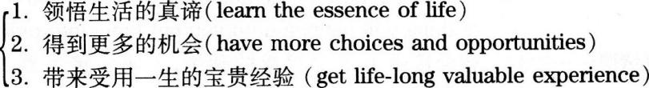
三、提出问题和建议

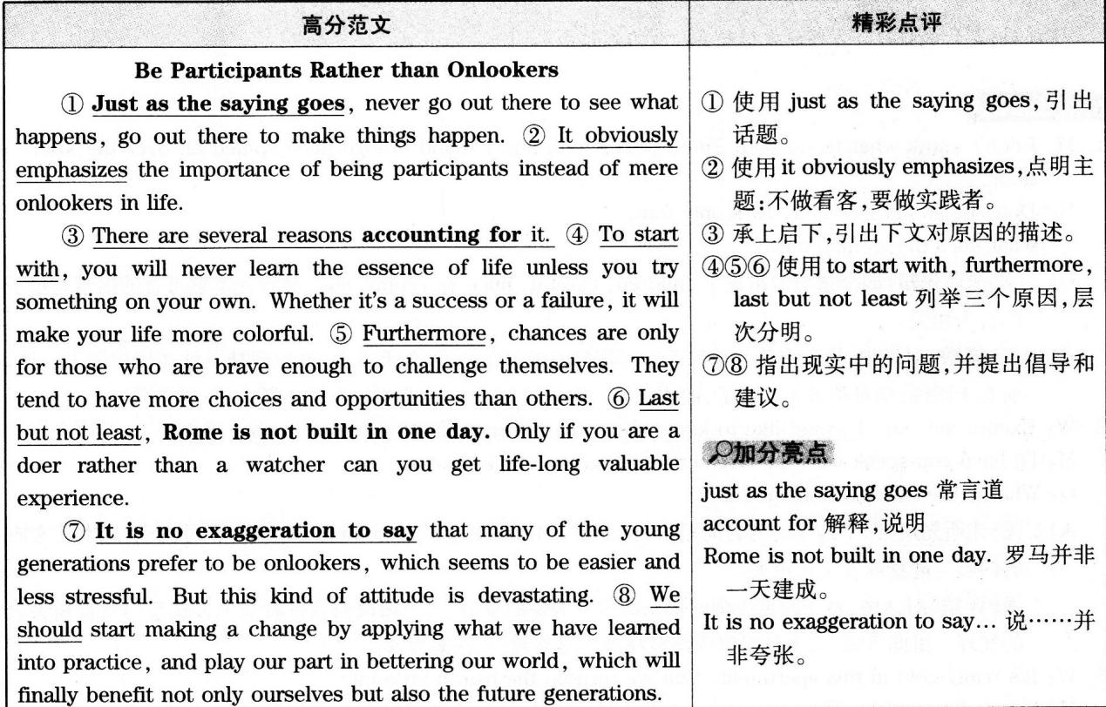
主题词汇
put…into practice将……付诸实践
carry out执行；实现
gain获得
accumulate积累
gradually逐渐地
make a progress取得进步
theory理论
action行动
would rather…than比起……更情愿……
stand by袖手旁观
句式拓展
1.For some people, watching what happens to others is good enough to learn a lesson, while for others, only practicing by themselves can finally make them get the real skills in
对一些人而言，看发生在别人身上的事情足以让他们吸取教训，而对于其他人而言，他们只有亲身实践才能最终得到生活中的真正技能.
2.No matter how many authentic theories you've got before,
nothing will happen until you put them into practice.
无论你曾经接受了多少权威的理论，若不付诸实践，一切都无济于事.
Part ⅡListening Comprehension

M: I don't know what to do with Timmy.This morning I found orange juice spilled all over the kitchen floor.
W: Don't be so hard on him.He's only four.
Q: What does the woman mean?
C.四个选项中出现了children，careful，juice和Timmy等词，故推测本题考查的内容与孩子的行为相关.
对话中，男士抱怨说他都不知道该拿蒂米怎么办了，今天早上，他发现桔子汁在厨房洒了一地，而女士则说，别对蒂米太严厉了，他才四岁.由此可见，女士认为男士不用小题大做，故答案为C..
2.W: Excuse me, sir.I would like to know about the fitness training program in your club.
M: I'll have you speak with the director in charge of new accounts.
Q: What is the woman interested in?
A.四个选项均为名词短语，且出现了fitness，job，computer和club等词，故推测本题考查的内容与健身或者工作相关.
对话中，女士向男士询问俱乐部健身锻炼的事情，男士则说他会带着女士去找专门负责新会员的经理.由此可知，女士是对俱乐部健身锻炼感兴趣，故答案为A..
3.W: It's really cold in this apartment.Can we turn up the heat a little bit?
M: Sorry.I've run out of money and can hardly pay the fuel bill.Maybe you'd better put on a sweater.
Q: what does the man mean?
B.四个选项中出现了sweater，save，fuel bills和heating等词，故推测本题考查的内容与寒冷天气以及取暖相关.
对话中，女士说她觉得很冷，问能不能把暖气开大一点，而男士则表示抱歉，说自己没钱了，都快付不起燃料费账单了，建议女士穿上毛衣.由此可知，男士想要节省燃料费，故答案为B.
4.M: I'm sorry, Miss.But you have to come with me to the security office.The video cameras in our shophave recorded everything you did.
W: No, no.I...I didn't do anything.I'll call the police if you dare insult me.
Q: What does the man think the woman was doing?
A.四个选项均为动名词短语，且出现了theft，pictures，shopping和camera等词，故推测本题考查的内容与商店里发生的事情相关.
对话中，男士要将女士带到保安室去，并说商店里的摄像头已经把女士所做的事都录下来了，而女士则表示自己什么都没有做，如果男士敢侮辱她的话，她就报警.由此可知，男士认为女士偷了商店里的东西，故答案为A.
5.M: I think you ought to see a doctor right away about that cough.
W: Well, I'll wait a few more days.I'm sure I'll get over it soon.
Q: What do we learn about the woman?
B.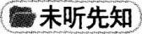选项均以she开头，且出现了medicine，doctor和cough等词，故推测本题考查的内容与女士的健康状况相关.
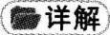男士说女士应该马上去看医生，而女士则说再等几天，她相信自己的咳嗽很快就会好的.由此可知，直到本对话发生时，女士都还没有去看医生，故答案为B..
6.M: I've heard that Pamela made quite a few mistakes in her lab report.
W: Well, she wouldn't have if she hadn't been in such a hunt to get it done.
Q: What does the woman imply?
D.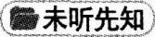四个选项均提到了Pamela，且出现了report，hurry，writing和mistakes等词，故推测本题考查的内容与帕米拉的报告相关.
对话中，男士说他听说帕米拉的实验报告出了很多错，而女士则说，如果她不是那么急着做完的话，就不会出这么多的错.由此可知，帕米拉实验报告中的错误本来是可以避免的，故答案为D..
7.M: We'd better check out before 12 o'clock, Marry.And now there are only 30 minutes left.
W: Let's hurry up.You go pay the bill and I'll call the reception to have our luggage taken downstairs.
Q : Where did this conversation most probably take place?
C.四个选项均是表示地点的介词短语，故推测本题考查的内容与对话发生的地点相关.
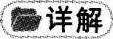对话中，男士说他们最好能在中午l2点之前退房，现在只剩半小时了，女士建议加快速度，并让男士去付账，她自己给前台打电话，叫人把行李送到楼下.由此可知，对话发生的时候，两人还没有开始办理退房手续，还在宾馆的房间里，故答案为C..
8.W: Have you ever heard this speaker before?
M: Yeah.She's excellent.She gets her point across and it's entertaining at the same time.
Q: what does the man say about the speaker?
D.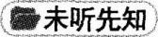四个选项均以she开头，且出现了college，works，speech和message等词，可以推测本题考查的内容与女士的情况相关.
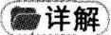对话中，女士问男士以前是否听过这个演讲者的讲座，男士说他听过，并认为这位演讲的女士很棒，她不仅将自己的观点表达得很清楚，而且讲得很有趣.由此可知，这位女演讲者擅长传达自己想要传达的信息，故答案为D..
Conversation One
M: (8) What should I do about Mr.Romero? Remember? He said it was important and couldn't wait.I thinkhe may want you for that new movie he's directing.
W: That's absolutely correct.(9) Now, we have to fit him in somewhere.Uh...what does Monday morninglook like?
M: That doesn't look so good.You have a make-up session starting at 6:00, then filming starts at 8:00, andthat's going to take the whole morning.
W: Well, what's after that?
M: (10) You have lunch with your agent to discuss the awards ceremony and you'll have to meet him at oneo'clock at the restaurant.
W: Oh, terrific! Listen.I cannot miss that.But I still have to make time for Mr.Romero.
M: Well, now, don't forget you got a three-o'clock appointment with your fashion designer.
W: That's right.You know he's showing the latest fashions from Japan? You know that loose-fitting look?
Those clothes are so in this year.
M: At 4:30 you have an appointment with your hairdresser.Then at 7:00, you have dinner with a journalist. Now remember, be nice to that guy.
W: Do I have to? That won't be easy and it's likely to run late.How does Tuesday look?
M: Well, you have to spend the whole morning at the photographer's.They are taking photos to publicize yournew movie.
W: What about the afternoon? Am I free then?
M: Let me see...Yes, you are free after 3:30.
W: Then you can set up a meeting with Mr.Romero at 4:00.
M: OK.(11) I'll get on it right away.
预览三道题各选项，其中出现了the woman’s appointment，hertravel，awards ceremony和make-up session等词，因此推测对话内容可能与女士的工作安排相关.
9.What are the speakers doing?
A.对话开头男士说罗梅罗先生急着见女士，可能是想让女士出演他导演的新电影，女士说一定得把他安排进来.由此可以推断，对话中的两人正在安排女士的时间，好让她能够与罗梅罗先生见面，故答案为A..
10.What is the woman going to discuss with her agent over lunch on Monday?
B.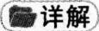对话中，男士告诉女士她周一需要和自己的经纪人吃午饭，讨论一下关于颁奖仪式的事情，故答案为B..
11.What do we learn from the conversation about the man?
C.对话中，男士和女士一起讨论女士的日程安排，从第一句罗梅罗先生想要让女士出演他导演的新电影可知，女士是位电影演员，而男士对女士的日程安排非常了解，并且由最后一句可知，男士服从女士的安排.综合这些内容可以推断出，男士是女士的助理，故答案为C..
Conversation Two
M: I'm phoning up about this job you advertised in the paper.This...er...young sales manager?
W: Oh, yes.
M: I'd like to apply for it.Would you send me an application form?
W: (12) No.You simply send in a written application, a letter.
M: Can you tell me a bit more about the job?
W: (13) Well, we are very looking for someone who isn't too concerned about working fairly long hours.
M: What do you mean by long hours?
W: (13) This is a job which does, as the advertisement says, have travel possibilities, and very often, one would be away at weekends, for instance.
M: Oh, I thought you meant working in the evenings and working overtime.
W: Well, it could also mean working in the evenings.But for a managerial post, I'm afraid we don't pay overtime.Um...that's for other grades.
M: Oh.What kind of money are you paying then?
W: (15) Well, this is to be negotiated.Uh, it depends partly on your experience and education.Perhaps youcan tell me briefly what that is?
M: I've just left school and got A level in geography.
W: Oh, I see.
M: (14) And it's the travel that appeals to me.That's why I'm inquiring about the job.
W: Yes, I see.What sort of a salary were you thinking in terms of?
M: Starting off, I thought it would be something like ￡ 500 a week?
W: Well, send in a written application and then we'll consider your case along with all the other applicants.
M: All right.Many thanks.Goodbye.
W: Bye.
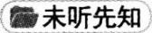预览四道题各选项，其中出现了interview，application，experienced，pay和working hours等词，由此推测对话可能与工作求职相关.
12.What does the woman say an applicant should do first to apply for the job?
B.对话开头，男士表示他对女士公司销售经理的职位感兴趣，请女士给她发一份申请表，而女士则让男士直接寄一封书面的求职申请信.因此，如果男士想要申请这份工作，他首先应该做的就是寄一份书面申请信，故答案为B..
13.What kind of a person is the company looking for?
D.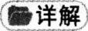对话中女士明确说，他们需要能够长时间工作的员工，而当男士要求她再进一步解释的时候，她说这份工作经常需要在周末出差.由此可知，这份工作需要能够在非正常工作时间加班，故答案为D.
14.What does the man like most about the job?
A.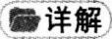对话中，男士明确表示职位广告中出差这一要求吸引了他，这也正是他想要得到这份工作的原因，故答案为A..
15.What does the woman say about the salary if the man is accepted by the company?
D.对话中男士问到了薪水问题，而女士回答说这还有待讨论，部分取决于男士的工作经历以及教育背景.由此可以推断，即使男士得到了这一职位，他的薪水待遇也不是明确规定好了的，而是得再商议，故答案为D..

Passage One
(16) A typical large supermarket offers around 17,000 to 20,000 items for sale and it wants to make sure that its customers see as many of them as possible. That's why you'll normally find essential goods like bread, vegetables and meat in completely different parts of the store.(17) Products with a high profit margin are always placed on shelves within easy reach of the customer, while lower margin items like sugar or flower are on the top or bottom shelves .Many people make shopping list before they visit supermarkets.(18) But even so, around 60% of all supermarket purchases are the result of decisions that are taken in the store. For this reason, supermarkets try to attract their customers by placing certain kinds of product next to each other. In the UK, beer will often be found next to items for babies because research shows that fathers of babies buy them on their way home from work and will buy beer at the same time. Research has also shown that this kind of impulse buy happens more frequently when no sales assistants are nearby. Supermarkets have made selling such a fine art that their customers often lose all sense of time.( 19 ) When interviewed, customers normally guess they've only spent half an hour in the supermarket even when they have been there for over 45 minutes.
But that shouldn't be too surprising. Any really profitable supermarket knows that it should keep its clocks well hidden.
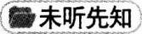预览四道题各选项，由选项中出现的customers，shelves，buy，shopping lists和bargains等词，可以推测短文可能与购物行为相关.
16.Why are essential goods displayed in totally different parts of the supermarket?
B.短文开头提到，超市希望顾客看到尽可能多的商品，这就是为什么他们会把生活必需品分散摆放的原因，故答案为B..
17.Where are goods with a high profit margin usually found?
C.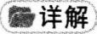短文中提到，利润高的商品所摆放的位置都是顾客容易够到的地方，也就是在那些容易接触到的货架上，故答案为C.
18.What does the speaker say about supermarket goers?
A.短文中提到，虽然很多人在去超市之前会列一张购物清单，但还是有60％左右的购买行为是在购物现场决定的.因此，大部分去超市购物的人都有冲动消费的行为，故答案为A.
19.What shouldn't be too surprising according to the speaker?
D.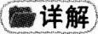短文临近结尾时提到了一次采访，接受采访的顾客通常感觉自己仅在超市里待了半个小时，而实际上他们已经待了超过45分钟了.因此，调查发现，顾客在超市中没有了时间感，而这一现象并不奇怪，故答案为D.
Passage Two
(20) When Matty Sallin was working on a degree in art and technology at university, he got an interesting assignment in electronics class: Create something for the household. He decided to create an alarm clock.
"Everybody has to use an alarm clock of some kind every day, and it's extremely unpleasant!" he says.(21)
He asked different people what they'd like to wake up to instead of a noisy alarm .A lot of them said, "The smell of bacon." (22) So Sallin invented a new kind of alarm clock: a wooden box with a pig face and a digital clock that uses the smell of cooking bacon rather than sound to wake someone up. He explains, "There's no danger of burning, because I built it carefully.It uses light bulbs instead of a flame for cooking and turns off automatically after ten minutes." Just a few easy steps are required to set the "alarm"."What you do is put in a couple of frozen strips the night before," says Sallin. Bacon is preserved, so there is no danger of its spoiling overnight."If you set the alarm for 8: 00, it will turn on at 7: 50 and slow cook for ten minutes under the bulbs," he says. Then the bulbs turn off and a fan blows the smell out through the nose of the pig."So instead of an alarm, you smell yourself awake," says Sallin."Then you can open the door on the side and pull the bacon out and eat it."
预览三道题各选项，由选项中出现的designs，clocks，alarm clock，pig face，automatic mechanism和manufacturing process等词，可以推测短文的内容与某种闹钟的创新设计相关.
20.What was Matty Sallin doing when he created an alarm clock?
C.短文一开始就说，马蒂·赛尔林在大学攻读艺术和技术学位时，曾有一项有趣的任务是发明家用器具，因此，他决定发明一个闹钟.由此可知，他当时还在读大学，故答案为C.
21.What did Matty Sallin do before making the new type of alarm clock?
D.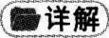短文中提到，在马蒂·赛尔林决定设计一款新闹钟时，他先征求了不同的人关于闹钟的想法，然后才开始动手制作，故答案为D..
22.What makes the newly invented alarm clock so unique?
C.短文提到，在征求了多人的意见后，赛尔林发现人们对闹钟感到最不满的是它吵闹的叫醒方式，而且人们最希望在受到烤腌肉香味的诱惑中醒来，所以，他才自己动手创造出了一款能够定时烤制腌肉，然后将香味散发出去，使人从梦中醒来的闹钟，故答案为C..
Passage Three
Most people feel lonely sometimes, but it usually only lasts between a few minutes and a few hours. For some people, though, loneliness can last for years. Psychologists are studying this complex phenomenon and have identified three different types of loneliness.
The first kind of loneliness is temporary.It usually disappears quickly and does not require any special attention. (23) The second kind, situational loneliness, is a natural result of a particular situation, for example, a divorce or moving to a new place. Although this kind of loneliness can cause physical problems, it
usually does not last for more than a year. Unlike the second type, the third kind of loneliness usually lasts more than two years and has no specific cause.(24) People who experience habitual loneliness have problem socializing and becoming close to others. Unfortunately, many of them think there is little or nothing they can do about it.
Psychologists agree that one important factor in loneliness is a person's social contacts, for example, friends, family members, etc. We depend on various people for different reasons. For instance, our families give us emotional support and our friends share similar interests and activities. However, psychologists have found that the number of social contacts we have is not the only reason for loneliness. It is more important how many social contacts we think or expect we should have.( 25 ) In other words, though lonely people may have many social contacts, they sometimes feel they should have more.They question their own popularity.
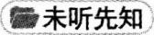预览三道题各选项，其中出现了大量带有负面含义的词，如cannot mix well，irrationally annoy，depend heavily on，blame others，doubt和psychologically weak等，并且第23题的各选项中还出现了treatment一词，据此推断本文可能与某种不正常的精神状态相关.
23.What does the speaker say about situational loneliness?
A.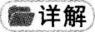短文中提到了三种类型的孤独，其中第二类为情景孤独，而短文中在对这一类孤独的介绍中指出，它通常是由于环境的变化所引起的，故答案为A..
24.What problem will people have if they experience habitual loneliness?
A.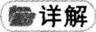短文中在提到habitual loneliness时说，那些经历习惯性孤独的人在社交方面存在问题，无法亲近他人，也就是说，他们不合群，不能与他人融洽地交往，故答案为A..
25.Why do some people suffer loneliness according to psychologists?
B.短文末尾部分提到，心理学家发现，虽然孤独的人可能有许多社交，但他们有时觉得自己应该有更多的社交，他们质疑自己的受欢迎程度.故答案为B..

26.locked away.此处应该填人动词的过去分词或词组，与句中的typed并列，构成被动语态.locked away意为“把……锁起来”.
27.forgotten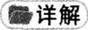此处应该填入动词过去分词构成的形容词，表示状态.forgotten意为“被遗忘的”.该句指出，个人信息放在那里多年，根本就没有重见天日的机会.因此，它们是“被遗忘的”.
28.Responsible for.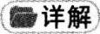该空所在句是一个倒装句，其正常语序应该是The astonishingly 29development in recent years of the computer has been 28 the change.所以该空应该填人一个形容词或词组作表语.responsible for意为“对……负责，对……承担责任”.
29.swift.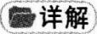此处应该填入形容词，被副词astonishingly修饰的同时，修饰名词development，合在一起，表示“惊人地快速发展”.swift意为“快速的”.
30.collected.此处应该填入动词的过去分词，与is一起构成被动语态.collected意为“收集”.
31.institutions.此处应该填入一个名词，被lending修饰.institutions意为“机构”.
32.government agencies.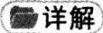此处应该填入一个名词或名词词组，与前面的名词或词组并列.government agencies意为“政府机构”.
33.invasion .此处应填入一个名词，被形容词frightening修饰.invasion意为“侵犯”.
34.efficient.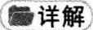此处应填入一个形容词，被前面的副词increasingly修饰.efficient意为“有效率的”.
35.questioned.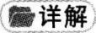此处应填人一个形容词或动词分词形式作people的后置定语.questioned意为“被问到的”.
Part Ⅲ Reading Comprehension


名词：B.amount量；F.differences区别；G.favorite特别喜爱的东西；O.theories理论
动词：A.advocate提倡，主张；C.confirmed确认，批准；H.happening发生；K.obtaining获取；M.protest
抗议；N.rejected拒绝，驳回.
形容词：D.crazy发狂的，发疯的；E.definite确定的；G.favorite最喜欢的
副词：I.immediately马上，立即；J.naturally自然地；L.primarily主要地
36.G.favorite.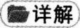形容词辨析题.该空前面是所有格形式baby’s，后面是名词toy，故推测空格处为形
容词.根据常识推断，婴儿的玩具一般都是他们喜欢的，故答案为favorite“最喜欢的”.备选形容词中，crazy
“发狂的，发疯的”和definite“确定的”均与句意不符，可以排除.
37.M.protest.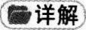动词辨析题.该空前面是情态动词may，故空格处应填入动词原形.根据下文可知，孩子认为妹妹分到了更多果汁，因此一定会表示不满，由此确定protest“抗议”为答案.备选动词中，只有两个动词原形，而advocate意思为“主张”，不符合句意，可以排除.
38.B.amount.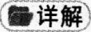名词辨析题.该空前面为冠词the，后面为介词of，故推测空格处应填入名词.根据句意：4岁大的孩子也许会抗议说妹妹分到了更多果汁，仅仅是因为玻璃杯的形状不同，而不是果汁的——.形状不同，也许容量是一样的，由此确定amount“量”为答案.备选名词中，differences“不同”和
theories“理论”均不符合句意，可以排除.
39.O.theories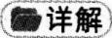名词辨析题.空格前为形容词child-sized，空格后为介词about，故推测该空格处为名词.根据句意：孩子们就像一些很棒的小科学家一样，总是会验证他们孩子们般大小的事物运转的——.由此可知，theories“理论”符合句意，故为答案.备选名词differences“区别”不符合句意，可以排除.
40.I.immediately.副词辨析题.空格前是will，空格后是test，故该空格处应填入副词.联系上下文，孩子一而再地把勺子扔到地上，直到父母说不再捡起，随后，孩子便有了各种疑问，故可知孩子会马上验证父母的话.由此确定immediately“马上，立即”为答案.备选副词中，naturally“自然地”和primarily"主要地”均不符合句意，可以排除.
41.D.crazy.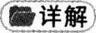形容词辨析题.空格前为drive you，可以联想到固定结构drive sb.+adj..根据上文可推知，孩子扔勺子继而试探家长的反应，并不是为了让他们抓狂，由此确定crazy“发狂的，发疯的”为答案.备选形容词definite“确定的”不符合句意，可以排除.
42.F. differences.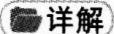名词辨析题.空格前为those，空格后是系动词are，故空格处应填人名词.上文提到，she is learning that her desires and yours Can differ“她正是在了解她的需求和你的需求是会不同的”，此处指不同之处，所以differences“区别”为答案.
43.J. naturally.副词辨析题.空格前为主语abilities和动词unfold，根据句子结构可判断空格处为副词.该句句意为：孩子们的认知能力会像花朵一样绽放，可知这一定是个自然的过程，由此确定naturally“自然地”为答案.备选副词primarily“主要地”不符合句意，可以排除.
44.H. happening动词辨析题.空格前为what else is，空格后为介词短语，故推测该空格处为动词
的分词形式或形容词.上文指出，孩子们的认知能力像花朵绽放一样，与生命中其他——的事情毫无关联.备选项中，happening“发生”符合句意，故为答案.备选的动词分词形式中，confirmed意思是“确认，批准”；obtaining意思是“获取”；rejected意思是“拒绝，驳回”，形容生活中的事情都太过于具体，不符合句意，可以排除.
45.N. rejected.动词辨析题.空格前是have been，空格后是or modified，故该空格处应填入动词的过去分词.根据句意，尽管多年来他的很多具体结论被——或是修改，他的想法仍然启发了全世界研究者们的诸多研究.由此确定rejected“拒绝，驳回”为本题答案.备选动词过去分词中，confirmed意思为“确认，批准”，不符合句意，可以排除.

46.The author was advised against the improper use of figures of speech.
作者被建议不要使用不合适的修辞.
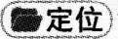由题干中的figures of speech定位到文章I段画线处.
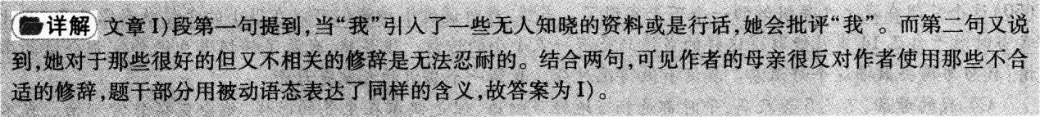
47.The author's mother taught him a valuable lesson by pointing out lots of flaws in his seemingly perfect essay.
作者的母亲通过指出他看似完美的论文中的错误，给他上了宝贵的一课.
由题干中的flaws和perfect essay定位到文章C.段画线处.
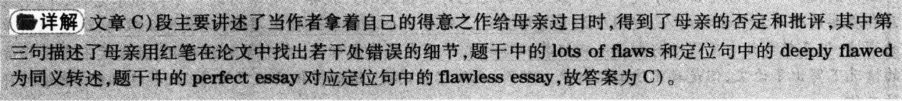
48.A writer should polish his writing repeatedly so as to get closer to perfection.
一个作家应该反复打磨自己的作品，从而更加接近完美.
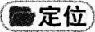由题干中的repeatedly和perfection定位到文章K段画线处.
49. Writers may experience periods of time in their life when they just can't produce anything.
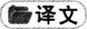作家们一生中也许会经历一段无法创作的时期。
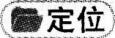由题干中的periods和can’t produce anything定位到文章E段画线处。
50. The author was not much surprised when his school teacher marked his essay as "flawless".
当作者的老师在他的论文上标记“完美”的时候，他并没有非常惊讶。
由题干中的not muchsurprised和marked his essay as“flawless”定位到文章B段画线处。
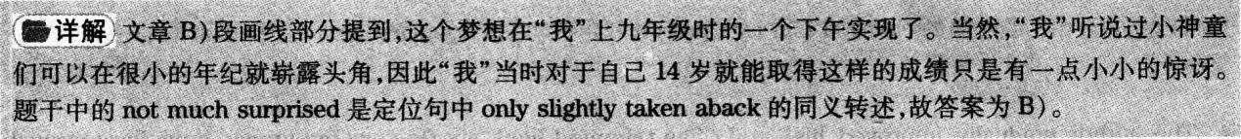
51. Criticizing someone's speech is said to be easier than coming up with a better one.
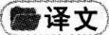批评一个人的言论据说比提出一个更好的容易一些。
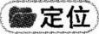由 题干中的criticizing someone’s speech和coming up with a betterone定位到文章F段画线处。
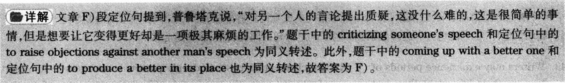
52.The author looks upon his mother as his most demanding and caring instructor.
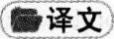作者将自己的母亲视为最严格和关心他的导师.
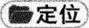由题干中的most demanding and caring instructor定位到文章A段画线处.
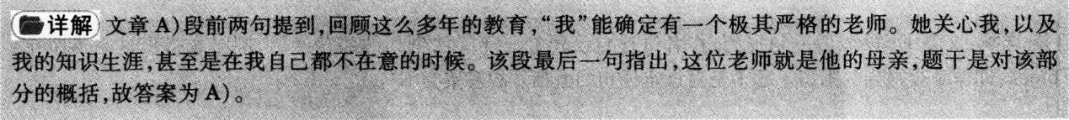
53.The criticism the author received from his mother changed him as a person.
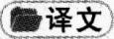作者从母亲那里得到的批评让他脱胎换骨地改变了.
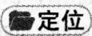由题干中的criticism和changed him as a person定位到文章H段画线处.
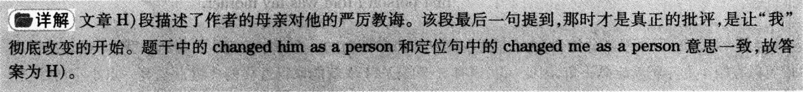
54.The author gradually improved his writing by avoiding fancy language.
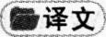作者通过避免使用华丽的语言，从而慢慢地提高了写作水平.
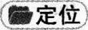由题干中的improved his writing和avoiding fancy language定位到文章J段画线处.
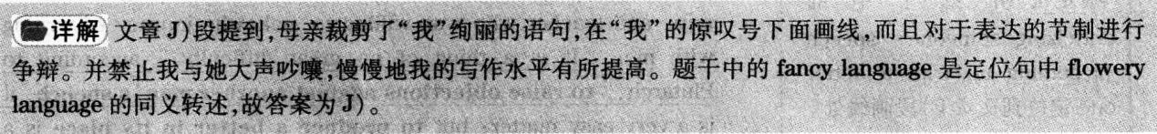
55.Constructive criticism gives an author a good start to improve his writing.
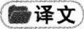建设性的批评给作者提高写作一个新的开始.
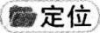由题干中的a good start和improve his writing定位到文章G段画线处.
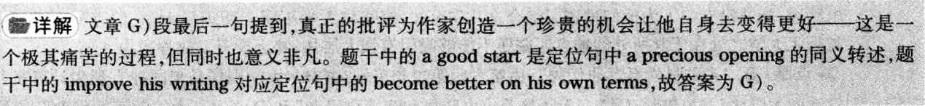

Passage One
56.A.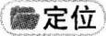由题干定位到第二段第一句：It wouldn’t be surprising if it were hard to reproduce in other countries，because you couldn’t reproduce it in most of the US either.
事实细节题.文章第二段第一句指出，如果说很难在其他国家复制它，这并不会令人惊奇，因为在美国的大部分地区你也不可能复制它.从这一句话中可以得知两个信息：在美国无法复制硅谷；在世界其他国家同样无法复制硅谷.因此硅谷在其他地方难以复制，故答案为A..
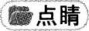B.“它是美国最大的技术中心”；C.“它在高科技领域的声誉无与伦比”和D.“它在信息技术方面领先世界”在文中均无体现，故均可排除.
57.B.由题干中的Miami定位到第五段第三句：Few startups happen in Miami，for example，because although it’s full of rich people.it has few nerds.
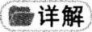事实细节题.文章第五段第三句提到，比如，在迈阿密很少有创业园区，因为尽管那里的有钱人比比皆是，但是痴迷科研的人却寥寥无几，即缺少合适的人才，故答案为B.
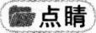A.“缺乏投资动机”；C.“缺少政府支持”以及D.“缺乏著名大学”在文中均未提及，故均可排除.
58.A.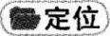由题千中的Carnegie-Mellon和different定位到第六段倒数第二句：But what did Carnegie-Mellon yield in Pittsburgh?
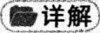推理判断题.文章第六段倒数第二句指出，但是卡内基.梅隆大学在匹兹堡开辟了什么呢?第七段最后两句表明，有钱人并不想住在匹兹堡或是伊萨卡.所以尽管此处有很多能够建立创业园区的电脑迷，却并没有一人为他们投资.综合这几句可知，康奈尔大学不同于斯坦福大学、伯克利大学和麻省理工大学之处在于其所处的地点匹兹堡不能够吸引有钱人居住，缺乏投资.故答案为A..
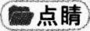B.“它的科学系远非优秀”，由第六段第二句可知，康奈尔大学同样是美国拥有顶尖计算机科学系的大学之一，故排除；C.“它无法培养出电脑迷和痴迷科研者”和D.“它不太注重商业创业”，在文中均未提及，故均可排除.
59.D.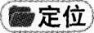由题干中的Boston定位到第七段第二句：The weather is terrible，particularly in winter，and there’s no interesting old city to make up for it.as there is in Boston.
推理判断题.文章第七段第二句提到，天气很恶劣，尤其是在冬天，而且又不像波士顿那样，有古老而有趣的城市可以弥补这一点.由此推断，波士顿的特点是古老和有趣，选项D.与原文意思相符，故为答案.
A.“它全年都有宜人的天气”B.“它在创造高科技的同时也创造了财富”以及C.“它不可能吸引很多的投资者和痴迷科研者”在文中均未提及，故均排除.
60.C.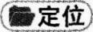由题干中的startup investors定位到第八段第四至六句：Startup investors are a distinct type of rich people.They tend to have a lot of experience themselves in the technology business.This helps them pick the right startups, and means they can supply advice and connections as well as money.
推理判断题.第八段第四句表明，创业园区的投资者是一群截然不同的有钱人.接着指出，他们自己往往有很多技术商业领域的经验.这一点能够帮助他们选择正确的创业公司，同时也意味着他们提供金钱的同时也能够提供建议和人际关系.选项C.“他们除了提供金钱外，还能做更多的事情”和原文意思一致，故为答案.
A.“他们在投资方面尤为精明”，文中只是提到他们能够选择正确的创业公司，并未提到精明，故排除；B.“他们与政府有着很好的关系”和D.“他们足够有钱给痴迷科研者投资”，文中均未提及，故均排除.
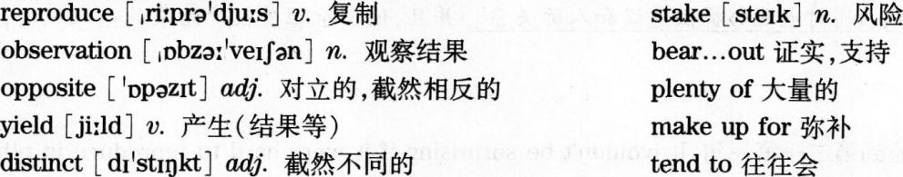
Passage Two
61.C.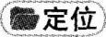由题干的like-minded定位到第一段第一句和第三句：It’s nice to have people of like mind around...Unfortunately, that comfort can hinder the very learning that can expand your company and your career.
事实细节题.第一段第一句提到，与志趣相投者为伴是一件好事.第三句指出，不幸的是，那种舒适会阻碍你学习扩展公司和发展事业的知识.故答案为C.
A.“它会帮助你的公司更加迅速地扩大”和定位句意思相悖，可以排除；B.“它会创造一个和谐的工作环境”和D.“它可能会让你不确定自己的决定”，文中均未提及，可以排除.
62.B.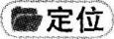由题干中的leaders定位到第三段第四句：As a leader，it can be challenging to create an environment in which people will freely disagree and argue, but as the saying goes: From confrontation comes brilliance.
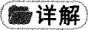推理判断题.定位句指出，作为一个领导，要创造一个人人都自由地辩驳和争论的环境是充满挑战的，但是常言道：冲突之下，必有精彩.根据but后面的内容可知，作者还是建议领导们创造这样的环境，故答案为B..
A.“避免和商业伙伴产生争论”，文中鼓励领导创造自由辩驳和争论的环境就是为了使员工积极地争辩，A.所述和文章意思不符，可以排除；C.“建立一个广而强的商业关系网络”和D.“从可以相媲美的竞争对手处寻求建议”，文中均未提及，可以排除.
63.A.由题干中的purpose和debate定位到第五段最后一句：The objective of this debating game is not to win but to get to the truth that will allow you to move faster, farther, and better.
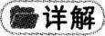事实细节题.第五段最后一句表明，这种辩论游戏的目的并不是赢，而是得到事实真相，能够让你更快更远更好地进步.故答案为A..
B.“增强人们的精神力量”，第五段提到辩论需要精神力量，这是条件，而非目的，故排除；C.“消除误解”，文中并未提及，可以排除；D.“寻找可以相媲美的对手”，文中第五段倒数第二句提到，一旦你有了可以相媲美的对手，制定一些基本规则，从而使大家都明白责任和底线.这并非辩论的目的，可以排除.
64.D.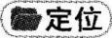由题干中的fierce debate定位到第六段第一句：Fierce debating can hurt feelings，particularly when strong personalities are involved.
事实细节题.第六段第一句表明，激烈的辩论会伤害感情，下文提出建议：确保跟你的竞争对手说清楚，这样他们就不会在争论话题之外还带有争论时的情绪.用笑容和幽默打破这种紧张，并强化一种观念：这是一种友好的交流，而所有的一切都是朝着一个共同的目标前进.这一切的举动都是为了避免伤害彼此的感情.故答案为D..
A.“他们认真地倾听对手的意见”、B.“他们对彼此的信念表示应有的尊重”以及C.“他们清晰直接地陈述自己的观点”，在文中均未提及，均可排除.
65.D.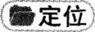由题干定位到第七段前两句：Reward all those involved in the debate sufficiently when the goals are reached. Let your sparring partners(拳击陪练)know how much you appreciate their contribution.
事实细节题.最后一段前两句指出，当目标达成时，要给予所有那些参与到辩论中的人充足的奖赏.让你的拳击陪练知道你是多么感激他的付出.选项D.“感谢他们的付出”与原文意思相符，故为答案.
A.“试图与他们和解”，文中提到奖赏和感激，而非和解，可以排除；B.“尽量弥补差距”，文中并未提及，可以排除；C.“邀请他们下次再来拳击场”，文中提到，他们对这种感激之情感受得越深，下次就会越愿意走上拳击台，C.所述与原文意思相悖，可以排除.

agreeableadj.一致的，符合的
battlefieldn.争论的问题
boostv.激发，促进
reinforcev.加强，强化
confrontationn.冲突，对抗
ringn.拳击台；摔跤台
staleadj.乏味的，没有新意的
dig out挖掘，找到
Part IV Translation
An annual Chinese speech contest for foreigners was held in Changsha this year, which proved to be a good way of promoting the cultural communication between China and other areas of the world.It offered young people all over the world a good opportunity to learn better about China.
A total of 126 contestants from 87 countries gathered in the capital of Hunan Province and took part in both the semi-final and the final from July 6 to August 5.
The competition was not the only activity.The contestants also got chances to visit the famous scenic spots and historical resorts in other parts of China.
1.翻译第一段第一句时，注意“举行了……比赛”可翻译为被动结构，需要用be held结构表示“举行”；此外，“一年一度”英译时用annual表示即可；“外国人汉语演讲比赛”切不可按照中文语序直接翻译，需要先译Chinese speech contest，再译for foreigners.
2.翻译第一段第二句时，注意该句的主语和前一句的主语都是“比赛”，故可以将其翻译为which引导的非限制性定语从句.另外，“证明是”译为proved to be；“文化交流”译为cultural communication；“……的好方法”译为a good way of….
3.翻译第一段第三句时，注意“更好地了解中国的机会”中“机会”为中心词，其他部分为定语，故翻译为a good opportunity to learn better about China.
4.翻译第二段时，注意该句中的定语成分较多，因此需要先找到句子主干，即“选手聚集在湖南省省会参加了半决赛和决赛”.“来自87个国家共计126位选手”中，“共计”译为a total of；“来自87个国家”译为from 87countries，作为定语放在contestants之后.“参加了半决赛和决赛”译为took part in both the semi-final and the final.
5.翻译第三段第二句时，“选手们还有机会……”的译法很多.一种是直接用contestants作主语，谓语用also get／have chances／opportunities to….另一种是用there be句型来表达，即there are also chances／opportunities for constants to….“著名景点和历史名胜”可译为the famous scenic spots and historical resorts.

附：最全历年英语四六级真题答案及下载大汇总！
http://www.233.com/cet4/zhuanti/linianzhenti/

